Notification Instructions

- Go to “Settings”

- Under “Your Preferences” click “Notifications”
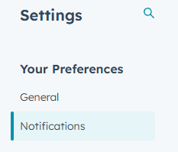
- Sroll down to the search bar under “What you get notified about” and type in “Assigned”
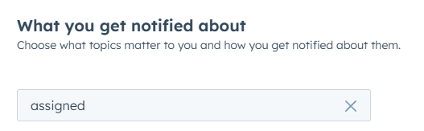
- Scroll to the “Companies and Contacts” section and uncheck the box on the right side for “Contacts assigned to you”
